**APPENDIX 1**

# TRAVEL-WEBSITE

END TERM REPORT

***by***

**Gourav Thakur**

**ANURAG SINGH**

Section: K22EG

Roll Number(s): 52, 30



### **Department of Intelligent Systems**

**School of Computer Science Engineering**

**Lovely Professional University, Jalandhar, Punjab**

December - 2022

**APPENDIX 2**

**Student Declaration**

This is to declare that this report has been written by me/us. No part of the report is copied from other sources. All information included from other sources have been duly acknowledged. I/We aver that if any part of the report is found to be copied, I/we shall take full responsibility for it.



Gourav Thakur

Roll number: 52



Anurag Singh

Roll number: 30

Place: Jalandhar, Punjab

Date: 02/02/22

**APPENDIX 3**

#### TABLE OF CONTENTS

|  |  |
| --- | --- |
| **TITLE** | PAGE NO. |
| **1. Introduction** | **5** |
| **2. Objectives of Project** | **10** |
| **3. Features of Project** | **11** |
| **4. Project Screenshots** | **12** |
| **5. Future Scope of Project** | **17** |

**APPENDIX 4**

BONAFIDE CERTIFICATE

Certified that this project report “TRAVEL WEBSITE” is the Bonafide work of “GOURAV THAKUR, ANURAG SINGH” who carried out the project work under my supervision.

**Bhupinder Singh**

Assistant Professor

ID: 28636

Department of

Intelligent Systems 1

Chapter - 1

INTRODUCTION:

**HTML** stands for Hypertext Markup Language. It was created by Tim Berners-Lee in 1991. The first version of HTML is HTML 2.0 which was published in 1999, and the latest version is HTML 5. We can save HTML files with an extension .html. It is the most basic language, and simple to learn and modify. It contains the elements that can change/develop a web page’s look and the displayed contents. Or we can say that HTML creates or defines the structure of web pages. We can create websites using HTML which can be viewed on internet-connected devices like laptops, android mobile phones, etc. It is a combination of both hypertext and markup language.

Text that is not restricted to a sequential format and that includes links to other text is called Hypertext. The links can connect online pages inside a single or different website.

Markup Language is a language that is interpreted by the browser, and it defines the elements within a document using “tags”. It is human-readable, which means that markup files use common words rather than the complicated syntax of programming languages.

HTML is the first language you should learn if you want to go for web development. HTML is a markup language that loads fast and is also light weighted. Whenever you use your browser to contact a server, you will receive a response in the form of HTML and CSS. Many tags are supported by HTML, making your web page more appealing and recognizable.

HTML5 has recently incorporated new tags and elements to aid in the development of professional-looking web pages.

Applications of HTML:

HTML is used for various purposes. Let us look at them

* Web Pages Development
* Embedding Images and Videos
* Game development
* Data entry support

**CSS** stands for Cascading Style Sheets, is a simple design language intended to simplify the process of making web pages presentable. Using CSS, you can control the colour of the text, the style of fonts, the spacing between paragraphs, how columns are sized and laid out, what background images or colours are used, as well as a variety of other effects. CSS handles the look and feel part of a web page. CSS is easy to learn and understand but it provides a powerful control over the presentation of an HTML document. Most commonly, CSS is combined with the markup languages HTML or XHTML.

.

Advantages of CSS:

* Multiple Device Compatibility

➢ Superior styles to HTML.

* CSS saves time
* Pages load faster

➢ Easy maintenance

CSS is created and maintained through a group of people within the W3C called the CSS Working Group. The CSS Working Group creates documents called specifications. When a specification has been discussed and officially ratified by the W3C members, it becomes a recommendation. These ratified specifications are called recommendations because the W3C has no control over the actual implementation of the language. Independent companies and organizations create that software.

The World Wide Web Consortium or W3C is a group that makes recommendations about how the Internet works and how it should evolve.

Cascading Style Sheets level 1 (CSS1) came out of W3C as a recommendation in December 1996. This version describes the CSS language as well as a simple visual formatting model for all the HTML tags.

CSS2 became a W3C recommendation in May 1998 and builds on CSS1. This version adds support for media-specific style sheets e.g., printers and aural devices, downloadable fonts, element positioning and tables.

**JavaScript** is a lightweight, cross-platform, and interpreted compiled programming language which is also known as the scripting language for webpages. It is well-known for the development of web pages; many non-browser environments also use it. JavaScript is both imperative and declarative type of language. JavaScript contains a standard library elements of objects, like [Array,](https://www.geeksforgeeks.org/arrays-in-javascript/) [Date,](https://www.geeksforgeeks.org/javascript-date-objects/) and [Math,](https://www.geeksforgeeks.org/javascript-math-object/) and a core set of language like

[operators,](https://www.geeksforgeeks.org/javascript-operators/) control structures, and [statements.](https://www.geeksforgeeks.org/javascript-statements/) JavaScript is also being used widely in game development and [Mobile a](https://www.guru99.com/mobile-testing.html)pplication development.

JavaScript was developed by Brendan Eich in 1995, which appeared in Netscape, a popular browser of that time. The language was initially called Live Script and was later renamed JavaScript.

Being a scripting language, JavaScript cannot run on its own. In fact, the browser is responsible for running JavaScript code. When a user requests an HTML page with JavaScript in it, the script is sent to the browser, and it is up to the browser to execute it. The main advantage of JavaScript is that all modern webbrowsers support JavaScript. So, you do not have to worry about whether your site visitor uses Internet Explorer, Google Chrome, Firefox, or any other browser.

To start with, you need a text editor to write your code and a browser to display the web pages you develop. You can use a text editor of your choice including Notepad++, Visual Studio Code, Sublime Text, Atom, or any other text editor you are comfortable with.

There are many programmers who think that JavaScript and [Java a](https://www.guru99.com/java-tutorial.html)re the same. In fact, **Java is a very complex programming language whereas JavaScript is only a scripting language**. The syntax of JavaScript is mostly influenced by the programming language C.

**Bootstrap** is an open-source and free CSS framework that helps in directing a responsive device-friendly mobile-first front-end webpage development tool. This tutorial series will teach you about Bootstrap and its various features.

Bootstrap mainly includes CSS (Cascading Style Sheets) and an optional JavaScript-supported design template (plug-ins) that deals with typography, buttons, forms, and other user interface components. This Bootstrap framework helps rapid web development and supports developers in creating responsive web pages.

Twitter Blueprint was the first name for Bootstrap and was developed on Twitter by Mr. Mark Otto and Jacob Thornton. It was released as an open-source product on GitHub in August 2011. The framework is primarily built to encourage design uniformity and reliability of web pages across applications. Before its existence, developers used various external libraries to perform responsive web development, leading to incompatibilities in web development and heavy maintenance burdens.

Advantages of Bootstrap:

* Responsive design and looks
* Easy customization
* Simple and easy to start
* Clean interface or Developers

Chapter-2

OBJECTIVES OF PROJECT:

The idea of doing business online over networks is nothing new. The main objective of this Travel Website is to facilitate all people who are busy with their work and to manage all the travel requirements of the customers while providing ease and sort of convenience to the customers and to add value to the travel sector.

Online business is a boom in the modern business. It is influencing both marketers and the customers. Our purpose is specifically established to take over the responsibility of planning and manging the travel requirements of the customers providing convenience to our travellers and adding value to their travel spend.

The reason behind our motivation is virtual reality has become another attraction point in the tourism industry. It gives guided tours of any place in the world. This will especially help travelers explore small and less-known places. By giving a 360-degree view of the different locations, travel companies and agents can let customers explore the ground before booking and increase the level of trust simultaneously with latest communications technology to provide the highest level of services, it provides best travel packages, capable of reserving the hotel of your choice and provides adventures activities.

Chapter-3

FEATURES OF PROJECT:

* Our website is clean and easy to use.
* Knowledgeable with booking option also.
* Cost effective.
* Customer review and easy booking option.
* Customer can access it from any device.
* Instant service.
* Multiple services options.

Chapter-4

PROJECT SCREENSHOTS:

Fig 1. Top view of home page



Fig 2. Packages section



Fig 3. Adventures Activity Section

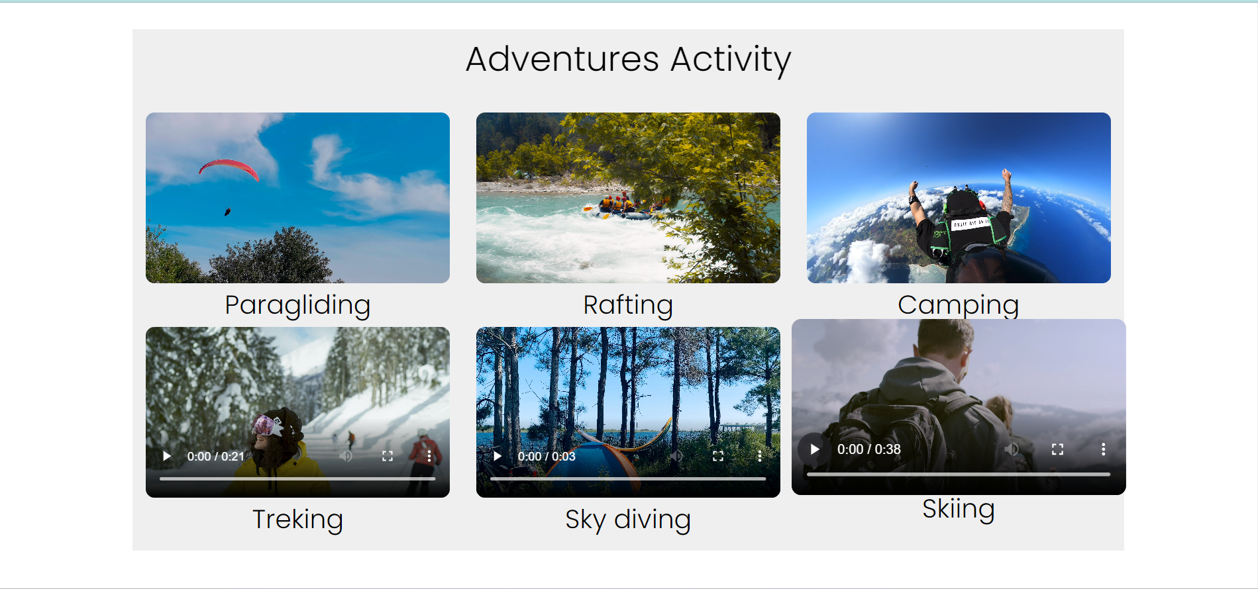

Fig 4. Booking Section



Fig 5. Review Section

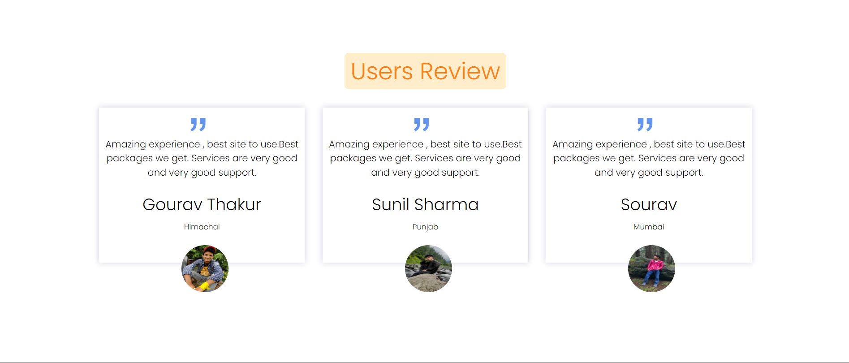

Fig 6. Footer Section

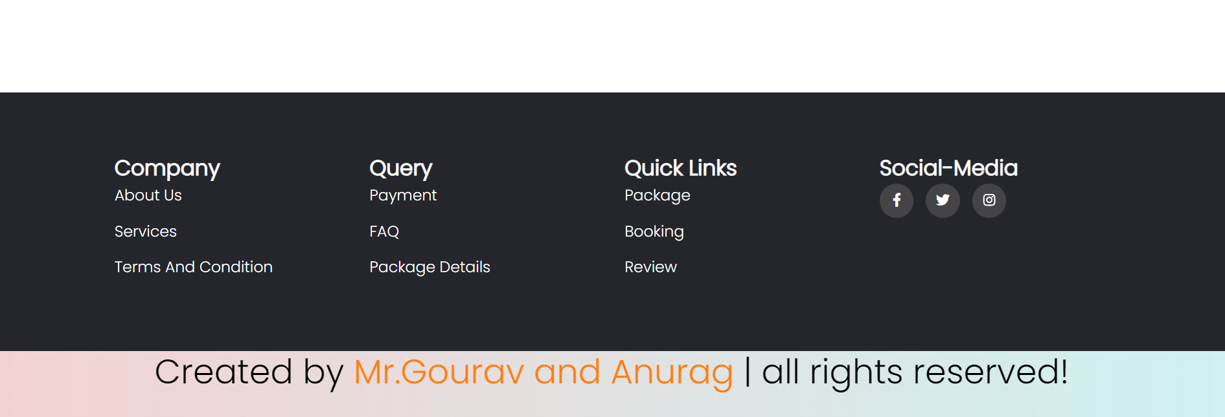

Fig 7. Login page

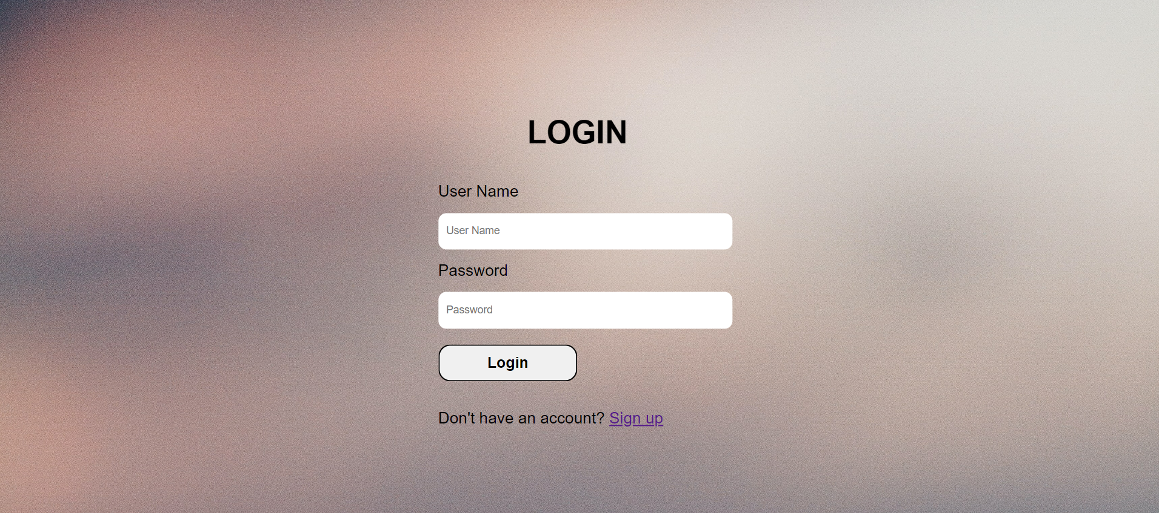

Fig 8. Book Now page

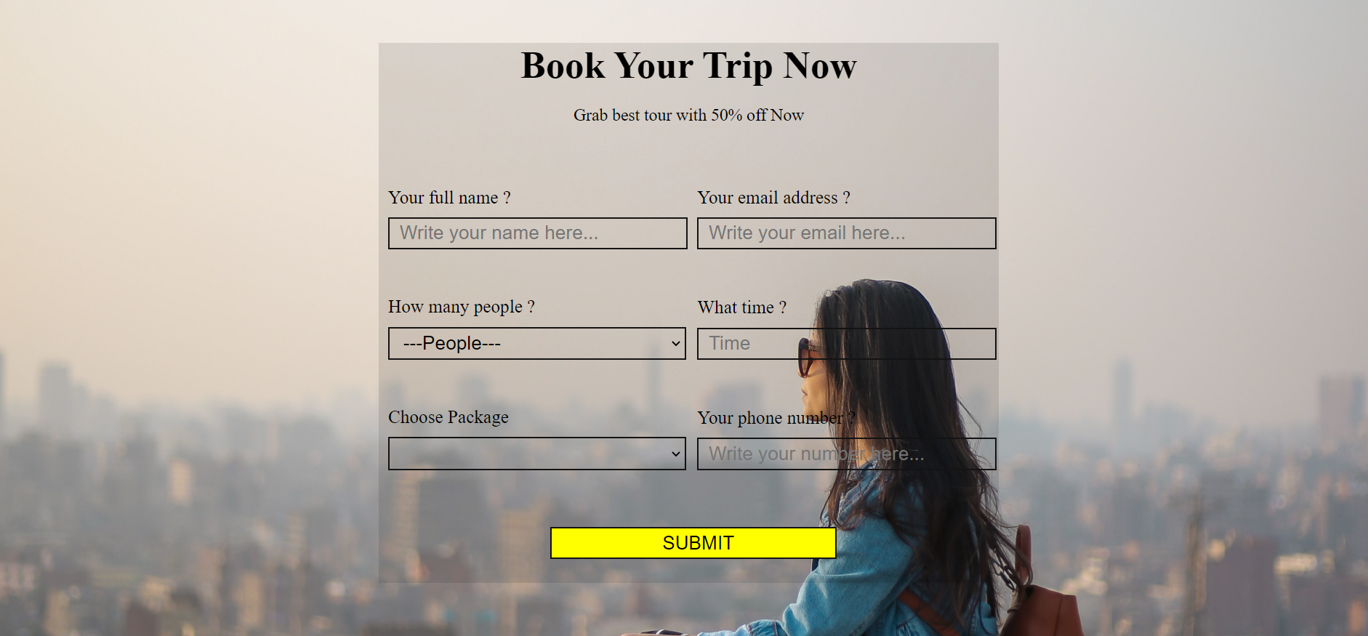

Chapter-5

FUTURE SCOPE OF PROJECT:

Today the world moves towards to be more digital, and digitization is the need of every business, every Industry. Travel Sites play a huge role informing people with latest trips and tours. People don’t have much more time to go to booking agency, so they always follow web sites or Electronic Media to do their work at home.

In a nutshell, it can be summarized that the future scope of the project circles around maintaining information regarding:

* We can give more advance software including more facilities.
* We will host the platform on online servers to make it accessible worldwide.
* We will add travel guides and more services like cars and bike rent, hotel booking etc.

The above-mentioned points are the enhancements which can be done to increase the applicability and usage of this project.